Data Base Management System
I. Relationships 3
1. Specialization 3
2. Generalization 3
3. Association 4
4. Aggregation 4
5. Composition 4
II. Relational Model 5
1. Relational model keys 5
a. Super Key 5
b. Primary Key 5
c. Candidate Key 6
d. Alternate Key 6
e. Foreign key 6
f. Surrogate Key 7
2. Integrity Constraints 7
a. Domain Constraints 7
b. Entity Constraints 8
c. Referential Constraints 8
d. Key Constraints 8
3. Relational Algebra 8
III. Transaction Control Language 8
1. COMMIT 9
2. SAVEPOINT 10
3. ROLLBACK 10
4. Locks 11
a. READ LOCK 11
b. WRITE LOCK 11
IV. Normalization 11
1. Functional Dependency 11
a. Armstrong’s axioms/properties of functional dependencies 12
b. Types of Functional Dependencies 13
2. Anomolies 13
a. Insertion Anomaly 13
b. Update Anomaly 13
c. Delete Anamoly 14
3. Normalization 14
a. First Normal Form (1NF) 14
b. Second Normal Form (2NF) 15
c. Third Normal Form (3 NF) 16
d. Boyce-Codd Normal Form (BCNF) 17
V. Indexing 19
VI. Joins 20
1. INNER JOIN 20

Relationships

Specialization
It is a process of specializing an entity type into a more specified entity.
In this process, we specialize a higher-level entity type by adding some additional attributes to the entity type.
It is a top-down approach in which a higher-level entity is broken into smaller entities.
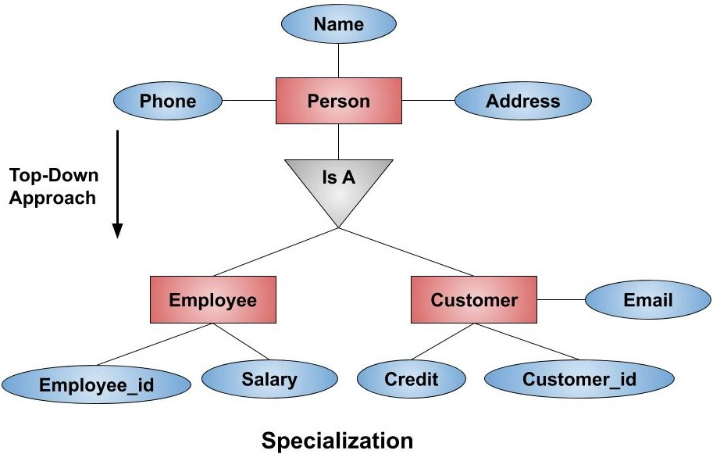

Generalization
It is a process of generalizing two or more lower-level entity types into a higher-level entity type. Entities are clubbed or grouped together to represent a more generalized view.
It is a bottom-up approach . It is the reverse process of Specialization.
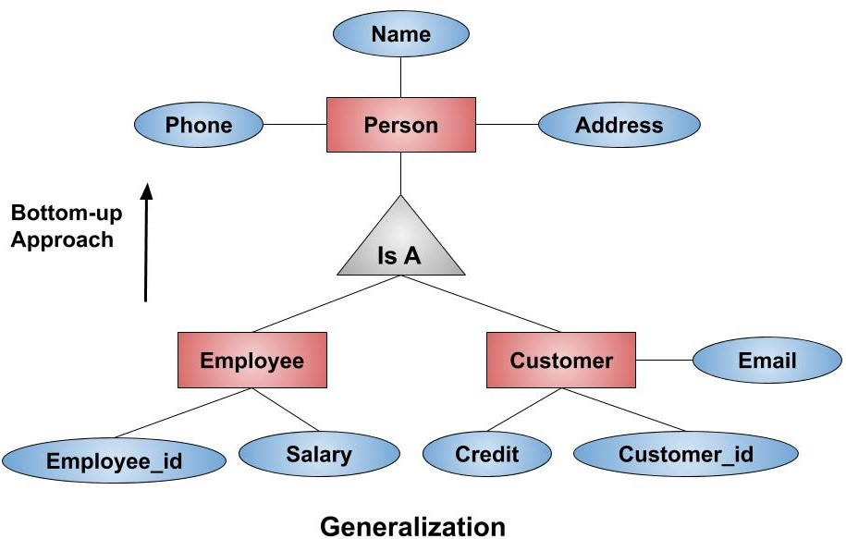

Association
Association is a general relationship (uses-a) between two independent classes. The objects in the relationship have their own lifecycles and no ownership is implied.
One object simply interacts with another. Neither owns the other.
Example : Teacher and a Student , If the teacher object is deleted, the student object still exists, and vice-versa.
Teacher simply uses Student.

Aggregation
Aggregation is a special form of association that represents a "whole-part" or "has-a" relationship with a weak ownership. The key characteristic is that the "part" objects can exist independently of the "whole" object.
Aggregation means one object contains another object.
However, the contained object can exist independently.
Example: Department and Professor
A department has professors.
But professors still exist even if the department is deleted.

Composition
Composition is a restricted, stronger form of aggregation where the "part" object's lifecycle is completely dependent on the "whole" object. The part object cannot exist meaningfully without the container object. It is a strong "part-of" relationship.
Composition is the strongest relationship.
The contained object cannot exist without the owner.
When the owner dies, its parts die too.
Example:
A House and a Room, A House is composed of Rooms. A Room cannot exist as an independent entity without being part of a House. If the House object is destroyed (e.g., demolished), the Room objects are also destroyed along with it.
Car and Engine also an example.

Relational Model
The relational model represents how data is stored in Relational Databases. A relational database stores data in the form of relations (tables).
STUDENT
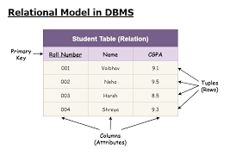

Relational model keys

Super Key
A superkey is a combination of columns that uniquely identifies any row within a relation/table.
It is a superset of all the key. It can have single attribute or multiple attributes which can be combined together as a unique set.
If a STUDENT relation has [stud_id, stud_name , stud_address,stud_phone]
{ stud_id }
{ stud_id , stud_name }
{ stud_id, stud_name , stud_address}
{ stud_id, stud_name , stud_address,stud_phone }
Etc.
So any permutation and combination (PNC) of the keys or attributes in a relation or a table can qualifies as a superkey.

Primary Key
It is a unique identifier which helps us to identify each and every tuple uniquely.
Tuple is any row in the table.
No two rows have the same primary key.
Every row has to have primary key, so primary key can not have a null value.
The primary key in the table cannot be changed.
Ex : stud_id

Composite Key
Primary key which is formed using at least two attributes.
{stud_name , stud_address} (this is one of the candidate keys)

Compound Key
Primary keys which are formed using two foreign keys which have been referenced in some other tables/relations.
Let us say STUDENT relation has [stud_id, stud_name , stud_address,stud_phone]
COURSE relation, it has [course_id, course_name ]
Here STUDENT does not have COURSE id and vice-versa.
Let us take
ENROLLMENT [stud_id, course_id,enrollment_fee]
If in ENROLLMENT we make { stud_id, course_id } as primary key it will become Compound key.

Candidate Key
The minimum set of attributes that can uniquely identify each tuple.
Candidate key can have a collection of more than one attribute to form a key.
Primary key is selected out of Candidate key.
Candidate Key value should not be null.
Example :
{stud_id}
{stud_name , stud_address}
can be the Candidate keys.

Alternate Key
All the candidate keys except the primary key are known as alternate keys.

Foreign key
It creates the relationship between two tables.
It helps us to cross reference between two tables.
It is also used to maintain data integrity consistency.
If a STUDENT relation has [stud_id, stud_name , stud_address,stud_phone]
Let’s take COURSE relation, it has [course_id, stud_id,course_name ] , here stud_id is the foreign key referencing to STUDENT relation.
Example :
-- Create the Customers table
CREATE TABLE Customers (
CustomerID INT PRIMARY KEY,
FirstName VARCHAR(50),
LastName VARCHAR(50)
);

-- Create the Orders table with a foreign key
CREATE TABLE Orders (
OrderID INT PRIMARY KEY,
OrderDate DATE,
CustomerID INT,
FOREIGN KEY (CustomerID) REFERENCES Customers(CustomerID)
);

Surrogate Key
To uniquely identify the data, generally we give a surrogate key as an integer.
Surrogate key also called a synthetic primary key, is generated when a new record is inserted into a table automatically by a database.
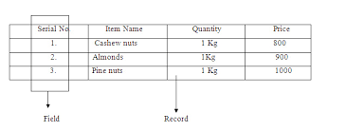

Integrity Constraints
Integrity constraints are rules that should be applied on database columns to ensure the validity of data.
With all the authorized changes to the database happening, integrity constraints ensure that there is no loss of data consistency.
There are three type of integrity constraints – 1. Domain Constraints 2. Entity Constraints 3. Referential Constraints

Domain Constraints
The domain integrity constraints restrict the value in the particular attributes of a relation.
Example: Let us say we need to ensure that semester student is registering for is one of fall, winter, spring or summer.
CREATE TABLE section (
course_id VARCHAR(8),
sec_id VARCHAR(8),
semester VARCHAR(6),
year NUMERIC(4,0),
building VARCHAR(15),
room_number VARCHAR(7),
time_slot_id VARCHAR(4),
primary key (course_id, sec_id, semester, year),
check (semester in (’Fall’, ’Winter’, ’Spring’, ’Summer’))
);

Entity Constraints
It puts constraints on Primary key i.e. primary should be unique and does not have NULL value.

Referential Constraints
It is specified between two relations and helps maintain consistency among the tuples of two relations.
This constriant is applied on the foreign key.
Foreign Key must be having the matching primary key or it must be NULL.
Rules

Insert Constraint
We can not insert a record in the child/referencing relation, If the corresponding record does not exist in the master/ referenced relation.

Delete Constraint
We can not delete the record from master/ referenced relation if the corresponding record lying in the child/referencing relation.

Key Constraints
- Not Null
- Unique
- Default
- Check
- Primarykey
- Foreignkey

Relational Algebra
- Selection (σ)
- Projection (π)
- Union (U)
- Intersection (∩)
- Set Difference (–)
- Cartesian Product (X)
- Rename (ρ) (alias)

Transaction Control Language
Transaction
Logical unit of work, like multiple correlated SQL statements also call it atomic unit.

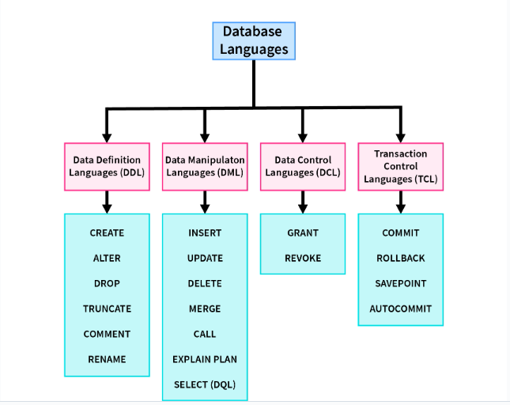

COMMIT

It saves all the work done.
It ends the current transaction and makes permanent changes during the transaction.
Some DBMS softwares by default set to AUTO COMMIT mode,we can change that setting .
>SET autocommit=OFF;
Consider the below sequence , COMMIT will save all the work done from START TRANSACTION till the end.
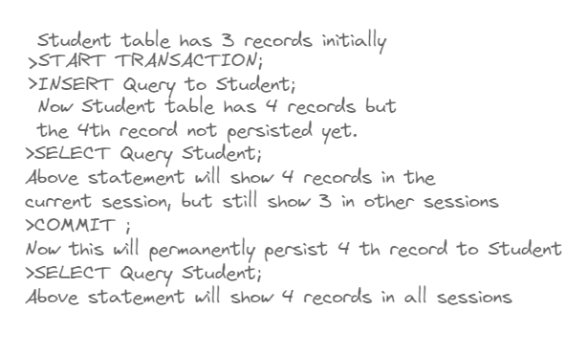

SAVEPOINT
This command saves the current state into save point. That save point can later be accessed.
>SAVEPOINT <savepoint_name>;

ROLLBACK
This commands uncommit all the changes or restore the current state to any previously saved state.
>ROLLBACK;
It restores the database to last committed state.
>ROLLBACK TO SAVEPOINT <savepoint_name>;
It restores the database to a particular savepoint state.
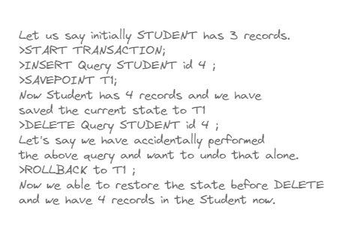

Locks

READ LOCK
This lock allows a user to only read the data from a table.
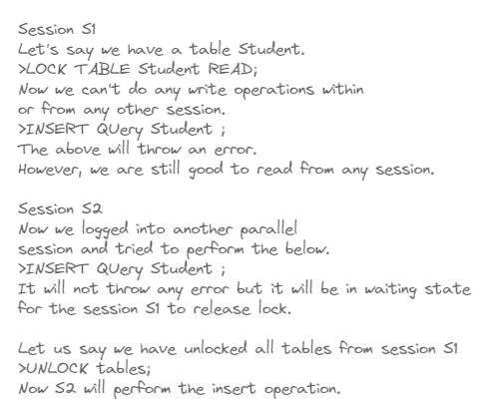

WRITE LOCK
- The only session which holds the lock of the table can read and write data both from the table.
- All other sessions cannot access the data of the table not even able to read until the WRITE lock is released from the holding session.
To get the list of active processes we can use the below command.
>SHOW PROCESSLIST;

Normalization

Functional Dependency
A functional dependency (FD) is a relationship between two attributes, typically between the primarykey and other non-key attributes within a table.
It is denoted as X → Y.
The attribute set on the left side of the arrow, X is called Determinant, while on the right side, Y is called the Dependent.
i.e X determines the value of Y , and Y value is dependent on X.
A functional dependency X->Y in a relation holds if two tuples having same value of attribute X also have same value for attribute Y.
Let us take relation R1 below
C1 | C2
1 | 1
2 | 4
3 | 9

C1 -> C2 holds here and also C2->C1 holds good too, as both C1 and C2 are having unique values.
Let us take relation R2 below
C1 | C2
1 | 1
2 | 4
3 | 9
4 | 9

Here only C1->C2 holds as C1 has unique values , C2->C1 does not hold as C2 have two values same (9) but corresponding values in C1 are different(3 , 4 ).
C1 | C2
1 | 1
2 | 4
3 | 9
3 | 9

Here both C1->C2 and C2->C1 holds good.

Armstrong’s axioms/properties of functional dependencies

Reflexivity
If Y is a subset of X, then X→Y holds by reflexivity rule
For example, {roll_no, name} → name is valid.

Augmentation
If X → Y is a valid dependency, then XZ → YZ is also valid by the augmentation rule.
For example, If {roll_no, name} → dept_building is valid, hence {roll_no, name, dept_name} → {dept_building, dept_name} is also valid.

Transitivity
If X → Y and Y → Z are both valid dependencies, then X→Z is also valid by the Transitivity rule.
For example, roll_no → dept_name & dept_name → dept_building, then roll_no → dept_building is also valid.

Types of Functional Dependencies

Trivial Functional Dependency
If a dependent is always a subset of the determinant.
i.e If A→ B and B⊆A

Non-trivial Functional Dependency
If the dependent is strictly not a subset of the determinant.
i.e If A→ B and A ∩ B = NULL

Multivalued Functional Dependency
If the attributes of the dependent set are not dependent on each other.
i.e. If a → {b, c} and there exists no functional dependency between b and c.

Transitive Functional Dependency
If a → b & b → c, then according to axiom of transitivity, a → c.

Anomolies
A database anomaly is an inconsistency in the data resulting from an operation like an update, insertion, or deletion.
There can be inconsistencies when a record is held in multiple places(redundancy) and not all of the copies are updated.

Insertion Anomaly
When certain attributes cannot be inserted into the database without the presence of other attributes.
stu_id | stu_name | stu_address | stu_club
220 | Annamalai | Kerala | yoga
220 | Muthu | Kerala | Music
231 | Mukesh | Mumbai | Crypto
232 | Muni | Karnataka | Public Speaking
232 | Muni | Karnataka | Arts

For example, in the above table if a new student named Nanda has joined the college and he has not enrolled in any club yet, we can't insert the data of Nanda into the table since the st_club field cannot accept null values.

Update Anomaly
when one or more instances of duplicated data are updated but not all.
stu_id | stu_name | stu_address | stu_club
220 | Annamalai | Kerala | yoga
220 | Muthu | Kerala | Music
231 | Mukesh | Mumbai | Crypto
232 | Muni | Karnataka | Public Speaking
232 | Muni | Karnataka | Arts

For student Muni as he belongs to two clubs at the college. If we want to change Muni's address, we must update it twice otherwise the data will be inconsistent.

Delete Anamoly
When certain attributes are lost due to the deletion of other attributes.
the college at some point closes the club crypto, then deleting the rows that contain s_club as crypto would also delete the information of student Mukesh since he belongs only to this department.
stu_id | stu_name | stu_address | stu_club
220 | Annamalai | Kerala | yoga
220 | Muthu | Kerala | Music
231 | Mukesh | Mumbai | Crypto
232 | Muni | Karnataka | Public Speaking
232 | Muni | Karnataka | Arts

Normalization
Normalization is the process of organizing the data by minimizing the redundancy from a relation or set of relations.
It is also used to eliminate undesirable characteristics like Insertion, Update, and Deletion Anomalies.
Normalization divides the larger table into smaller and links them using relationships.

First Normal Form (1NF)
For a Relation/table to justify 1NF it needs to satisfy 3 basic conditions
● Each attribute should contain atomic values. (i.e. No multivalued attributes)
● Each value stored in an attribute should be of the same type.
● All the attributes in a table should have unique names.

Relation EMPLOYEE is not in 1NF because of multi-valued attribute EMP_PHONE.

EMP_ID | EMP_NAME | EMP_PHONE | EMP_STATE
14 | John | 7272826385,  9064738238 | UP
20 | Harry | 8574783832 | Bihar
12 | Sam | 7390372389,  8589830302 | Punjab

The decomposition of the EMPLOYEE table into 1NF has been shown below:
EMP_ID | EMP_NAME | EMP_PHONE | EMP_STATE
14 | John | 7272826385 | UP
14 | John | 9064738238 | UP
20 | Harry | 8574783832 | Bihar
12 | Sam | 7390372389 | Punjab
12 | Sam | 8589830302 | Punjab

Second Normal Form (2NF)
It should be in First Normal Form.
It should not have any partial dependencies.
Course_Id | Stud_Id | Marks | Course_Name
CS101 | 1 | 10 | C Progamming
CS102 | 1 | 9 | Maths-I
CS103 | 1 | 8 | Maths-II
CS101 | 2 | 9 | C Progamming
CS102 | 2 | 8 | Maths-I
From the above table, if we need to know how much marks for Stud_Id got Stud_Id is not alone enough, we need the Course_Id also to determine in which course how many marks he has got.
So { Course_Id , Stud_Id } -> Marks
So here the primary key combination of { Course_Id , Stud_Id }.
Now if we need to know Course_Name for a particular Course_Id , the attribute Stud_Id is not required.
So Course_Id -> Course_Name
Partial Dependency :If one part of a composite primary key(we call it candidate key also) can independently determine another attribute.
The above table have partial dependency Course_Id -> Course_Name.
So the decomposition of the above table is as below (just take out the partial dependency from that in another table)

Course_Id | Stud_Id | Marks
CS101 | 1 | 10
CS102 | 1 | 9
CS103 | 1 | 8
CS101 | 2 | 9
CS102 | 2 | 8

Course_Id | Course_Name
CS101 | C Progamming
CS102 | Maths-I
CS103 | Maths-II

Third Normal Form (3 NF)
It should already be in the 2NF.
It should not have Transitive Dependency
A relation is in third normal form if it holds atleast one of the following conditions for every non-trivial function dependency X → Y.
- X is a super key.
- Y is a prime attribute, i.e., each element of Y is part of some candidate key. (no non-primary-key attribute is transitively dependent on the primary key)
So If an attribute is dependent on non-prime attribute then there might be transitive dependency.
ID | Name | State | Country
1 | Ram | Andhra | India
2 | Rahul | Texas | USA

Let us see if above table has transitive dependency.
We can determine State from ID as ID is primary key.
ID State
We can also determine Country from State.
State Country
Now we should have ID Country, in otherwords Country is a non-primary attribute which is transitively dependent on the primary attribue ID.
How to decompose? as we have the problem with Country we can take this out.
ID | Name | State
1 | Ram | Andhra
2 | Rahul | Texas

State | Country
Andhra | India
Texas | USA

Boyce-Codd Normal Form (BCNF)
It is an extension of 3NF and is also known as 3.5 Normal Form.
For a table to be in the Boyce-Codd Normal Form, it should satisfy 2 rules:
- It should be in the Third Normal Form.
- For every functional dependency X → Y, X is the super key of the table.
So it is stricter than 3NF.
A prime attribute shouldn’t be dependent on /derived from a non-prime attribute, so LHS should be always superkey.

Student | Course | Tutor
101 | Java | Raj
101 | Python | Ram
102 | Java | Raj
102 | Python | Raghu

Example for remembering purpose Student 2 repeating after each [{101 , 101 } {102 , 102 }]
For Course consecutively repeating {Java , Python}
For Tutor-> consecutively repeating just change the last value to Raghu [Raj , Ram , Raj , Raghu]
Here the primary key is composite of {Student, Course}
We have the following functional dependencies
{Student, Course} {Tutor}
Tutor Course (this is violating the BCNF as Tutor is not a superkey.)
To decompose the relation based on BCNF, We just need to use to link decomposed tables Tutor which has problem.
Student | Tutor
101 | Raj
101 | Ram
102 | Raj
102 | Raghu

Course | Tutor
Java | Raj
Python | Ram
Python | Raghu

Or also we can maintain a Tutor_Id to link both the decomposed tables.
Student | Tutor_Id
101 | 1
101 | 2
102 | 1
102 | 3

Tutor_Id | Course | Tutor
1 | Java | Raj
2 | Python | Ram
3 | Python | Raghu

Indexing
An index is a database structure that speeds up data retrieval.
Instead of scanning every single row in a table to find a specific record, the database uses the index to pinpoint exactly where the data lives on your disk.
How it Works
Creates a shortcut: When you create an index on a specific column (e.g., email), the database builds a separate data structure, usually a B-tree (balanced tree).
Sorts and maps: This tree contains only the data from that column, kept in a strictly sorted order, along with a "pointer" (the physical disk address) to the full row.
Traverses: When you run a query searching by that column, the database uses the sorted B-tree to find the value in log(n) time.
The Trade-off
While indexes drastically speed up SELECT (reading) queries, they slow down INSERT, UPDATE, and DELETE (writing) operations. Every time you add or change data, the database has to update the table and rebuild or update the index.
Furthermore, indexes require additional disk storage.

Joins
Joins are used to combine rows from two or more tables based on a related column between them. There are several types of joins, including INNER JOIN, LEFT JOIN (or LEFT OUTER JOIN), RIGHT JOIN (or RIGHT OUTER JOIN), and FULL JOIN (or FULL OUTER JOIN).

SQL joins are used to combine rows from two (or more) tables based on a related column.
Let's consider the below tables :
Employees

emp_id | name | dept_id
1 | Sesh | 10
2 | Ravi | 20
3 | Suresh | 30
4 | Neha | NULL

Departments

dept_id | dept_name
10 | HR
20 | IT
40 | Finance

INNER JOIN
An INNER JOIN returns only the rows where there is a match in both tables.
Returns only matching rows in both tables.
Or simply JOIN
Query
SELECT e.name, d.dept_name
FROM Employees e
INNER JOIN Departments d
ON e.dept_id = d.dept_id;

Result
name | dept_name
Sesh | HR
Ravi | IT

LEFT JOIN (LEFT OUTER JOIN)
All rows from left table + matching rows from right
Query

SELECT e.name, d.dept_name
FROM Employees e
LEFT JOIN Departments d
ON e.dept_id = d.dept_id;

Result

name | dept_name
Sesh | HR
Ravi | IT
Suresh | NULL
Neha | NULL

RIGHT JOIN (RIGHT OUTER JOIN)

All rows from right table + matching from left

Query

SELECT e.name, d.dept_name
FROM Employees e
RIGHT JOIN Departments d
ON e.dept_id = d.dept_id;

Result

name | dept_name
Sesh | HR
Ravi | IT
NULL | Finance

FULL OUTER JOIN

All rows from both tables (matched + unmatched)
SELECT e.name, d.dept_name
FROM Employees e
FULL OUTER JOIN Departments d
ON e.dept_id = d.dept_id;

name | dept_name
Sesh | HR
Ravi | IT
Suresh | NULL
Neha | NULL
NULL | Finance

CROSS JOIN

Cartesian product (every row with every row)

SELECT e.name, d.dept_name
FROM Employees e
CROSS JOIN Departments d;

Result (4 × 3 = 12 rows):

name | dept_name
Sesh | HR
Sesh | IT
Sesh | Finance
Ravi | HR
... | ...

Db Fiddle
https://www.db-fiddle.com/

Queries

Sample Schema :
CREATE TABLE employees (
emp_id INT PRIMARY KEY,
name VARCHAR(50),
email VARCHAR(100),
salary DECIMAL(10,2),
department VARCHAR(50),
manager_id INT
-- FOREIGN KEY (manager_id) REFERENCES employees(emp_id)
);

INSERT INTO employees VALUES
(1, 'Alice', 'alice@company.com', 120000, 'Engineering', 2 ),
(2, 'Bob', 'bob@company.com', 80000, 'Engineering', 3 ),
(3, 'Charlie', 'charlie@company.com', 95000, 'Engineering', 4 ),
(4, 'Diana', 'diana@company.com', 110000, 'Marketing', 5 ),
(5, 'Eve', 'eve@company.com', 75000, 'Marketing', NULL ) ;

emp_id | name | email | salary | department | manager_id
1 | Alice | alice@company.com | 120000.0 | Engineering | 2
2 | Bob | bob@company.com | 80000.0 | Engineering | 3
3 | Charlie | charlie@company.com | 95000.0 | Engineering | 4
4 | Diana | diana@company.com | 110000.0 | Marketing | 5
5 | Eve | eve@company.com | 75000.0 | Marketing | null

Find the Employees and their Manager information ?

SELECT e.emp_id as empId , e.name as empName , m.emp_id as managerId , m.name as managerName

FROM employees e LEFT JOIN employees m

ON e.manager_id = m.emp_id ;

empId | empName | managerId | managerName
1 | Alice | 2 | Bob
2 | Bob | 3 | Charlie
3 | Charlie | 4 | Diana
4 | Diana | 5 | Eve
5 | Eve | null | null

Find the Employees who earn more than their Manager?

SELECT e.emp_id as empId , e.name as empName , e.salary as empSalary , m.emp_id as managerId , m.name as managerName , m.salary as managerSalary

FROM employees e JOIN employees m

ON e.manager_id = m.emp_id AND e.salary > m.salary ;

empId | empName | empSalary | managerId | managerName | managerSalary
1 | Alice | 120000.0 | 2 | Bob | 80000.0
4 | Diana | 110000.0 | 5 | Eve | 75000.0

OR

SELECT e.name as empName , e.salary as empSalary
, m.name as managerName , m.salary as managerSalary

FROM

employees e LEFT JOIN employees m ON e.manager_id = m.emp_id

WHERE e.salary > m.salary ;

Sample Schema :
CREATE TABLE Department (
department_id INT PRIMARY KEY,
department_name VARCHAR(50)
);

INSERT INTO Department VALUES
(101, 'Engineering'),
(102, 'HR'),
(103, 'Finance'),
(104, 'Operations');

department_id | department_name
101 | Engineering
102 | HR
103 | Finance
104 | Operations

CREATE TABLE Employee (
emp_id INT PRIMARY KEY,
emp_name VARCHAR(50),
salary INT,
department_id INT,
FOREIGN KEY (department_id)
REFERENCES Department(department_id)
);

INSERT INTO Employee VALUES
(1, 'John', 120000, 101),
(2, 'Alice', 95000, 101),
(3, 'Bob', 110000, 101),

(4, 'David', 85000, 102),
(5, 'Eva', 92000, 102),

(6, 'Sam', 130000, 103),
(7, 'Tom', 100000, 103),
(8, 'Kate', 130000, 103),

(9, 'Mike', 70000, 104),
(10, 'Sara', 75000, 104),
(11, 'Chris', 80000, 104),
(12, 'Nina', 78000, 104);

emp_id | emp_name | salary | department_id
1 | John | 120000 | 101
2 | Alice | 95000 | 101
3 | Bob | 110000 | 101
4 | David | 85000 | 102
5 | Eva | 92000 | 102
6 | Sam | 130000 | 103
7 | Tom | 100000 | 103
8 | Kate | 130000 | 103
9 | Mike | 70000 | 104
10 | Sara | 75000 | 104
11 | Chris | 80000 | 104
12 | Nina | 78000 | 104

Get the highest salary in each department.
SELECT department_id,
MAX(salary) AS highest_salary
FROM Employee
GROUP BY department_id;

If you also want the department name

SELECT e.department_id , d.department_name , MAX( e.salary ) as maxSalary
FROM Employee e
JOIN Department d
ON e.department_id = d.department_id
GROUP BY e.department_id ;

department_id | department_name | maxSalary
101 | Engineering | 120000
102 | HR | 92000
103 | Finance | 130000
104 | Operations | 80000

If you want the employee(s) who earn the highest salary in each department
This handles ties as well. For example, if two employees in the same department both earn the highest salary, both rows will be returned.

SELECT e.*
FROM Employee e
JOIN (
SELECT department_id,
MAX(salary) AS max_salary
FROM Employee
GROUP BY department_id
) m
ON e.department_id = m.department_id
AND e.salary = m.max_salary;

emp_id | emp_name | salary | department_id | department_id | maxSalary
1 | John | 120000 | 101 | 101 | 120000
5 | Eva | 92000 | 102 | 102 | 92000
6 | Sam | 130000 | 103 | 103 | 130000
8 | Kate | 130000 | 103 | 103 | 130000
11 | Chris | 80000 | 104 | 104 | 80000

To get the 2nd highest salary in each of the department.
SELECT e.department_id , max(e.salary) as secondMax
FROM Employee e
JOIN (
SELECT department_id,
MAX(salary) AS max_salary
FROM Employee
GROUP BY department_id
) m
ON e.department_id = m.department_id
AND e.salary < m.max_salary
GROUP BY e.department_id ;

department_id | secondMax
101 | 110000
102 | 85000
103 | 100000
104 | 78000

Find the number of employees in each department.
SELECT e.department_id , count(*) AS count_per_dept
FROM Employee e
GROUP BY e.department_id ;

department_id | count_per_dept
101 | 3
102 | 2
103 | 3
104 | 4

Find the department with the highest employee count.

SELECT e.department_id , count(*) AS count_per_dept
FROM Employee e
GROUP BY e.department_id
HAVING
count_per_dept =
(
SELECT MAX( temp.count_per_dept )
FROM (
SELECT count(*) AS count_per_dept
FROM Employee e
GROUP BY e.department_id
) temp
) ;

department_id | count_per_dept
104 | 4
To get the department information also
SELECT d.department_id , d.department_name , count(*) as max_count
FROM Employee e
JOIN Department d
ON e.department_id = d.department_id
GROUP BY e.department_id
HAVING max_count = (
SELECT MAX( t.count_per_dept ) FROM
(
SELECT e.department_id , count(*) AS count_per_dept
FROM Employee e
GROUP BY e.department_id
) t
);
department_id | department_name | max_count
104 | Operations | 4

Find the highest salary without using MAX()

SELECT salary
FROM Employee
ORDER BY salary DESC
LIMIT 1;

Find the nth highest salary

SELECT DISTINCT Salary
FROM Employee
ORDER BY Salary DESC
LIMIT 1 OFFSET 1;

Sample Schema :

CREATE TABLE Employee (
employee_id INT PRIMARY KEY,
emp_name VARCHAR(50),
email VARCHAR(100),
department VARCHAR(50),
salary INT
);

INSERT INTO Employee VALUES
(1, 'John', 'john@example.com', 'IT', 90000),
(2, 'John', 'john@example.com', 'IT', 90000),

(3, 'Alice', 'alice@example.com', 'HR', 80000),
(4, 'Alice', 'alice@example.com', 'HR', 80000),

(5, 'Bob', 'bob@example.com', 'Finance', 85000),

(6, 'Sam', 'sam@example.com', 'Admin', 70000);

employee_id | emp_name | email | department | salary
1 | John | john@example.com | IT | 90000
2 | John | john@example.com | IT | 90000
3 | Alice | alice@example.com | HR | 80000
4 | Alice | alice@example.com | HR | 80000
5 | Bob | bob@example.com | Finance | 85000
6 | Sam | sam@example.com | Admin | 70000

Find duplicate emails in the employee table.

SELECT email , count(*) as email_count
FROM Employee
GROUP BY email
HAVING email_count > 1 ;

email | email_count
alice@example.com | 2
john@example.com | 2

Display duplicate records with their count

( The key is we need to know the what cols are duplicated )

SELECT emp_name , email , department , salary , count(*) as count
FROM Employee
GROUP BY emp_name , email , department , salary
HAVING count > 1 ;

emp_name | email | department | salary | count
Alice | alice@example.com | HR | 80000 | 2
John | john@example.com | IT | 90000 | 2

Delete duplicate records from the table.

Keep the latest record (highest employee_id) and delete older duplicates.

( except the max employee_id ( from group by clause ) , every other record gets deleted.

My SQL does not support this version :

DELETE FROM Employee
WHERE employee_id NOT IN (
SELECT MAX(employee_id)
FROM Employee
GROUP BY emp_name,
email,
department,
salary
);

So better wrap the subquery in another derived table

DELETE FROM Employee
WHERE employee_id NOT IN (
SELECT employee_id
FROM (
SELECT MAX(employee_id) AS employee_id
FROM Employee
GROUP BY emp_name,
email,
department,
salary
) t
);

SELECT * FROM Employee ;

employee_id | emp_name | email | department | salary
2 | John | john@example.com | IT | 90000
4 | Alice | alice@example.com | HR | 80000
5 | Bob | bob@example.com | Finance | 85000
6 | Sam | sam@example.com | Admin | 70000

( rows 1 , 3 got deleted )

